**Title:** Enhancing Medical Education: The Impact of Deliberate Practice on Learning Human Physiology

**Article type:** Original Article

**Author names:**

1. Júlia Silva Souza
2. Lavínia Penido Safe
3. Airton Martins da Costa Lopes
4. Augusto Scalabrini-Neto

**Degrees and Affiliations:**

1. Third – year Medical Student. Faculdade Ciências Médicas de Minas Gerais, Belo Horizonte, Brazil.
2. Third – year Medical Student. Faculdade Ciências Médicas de Minas Gerais, Belo Horizonte, Brazil.
3. MD. Faculdade Ciências Médicas de Minas Gerais, Belo Horizonte, Brazil.
4. MD. Faculdade Ciências Médicas de Minas Gerais, Belo Horizonte, Brazil.

**ORCID (Open Researcher and Contributor Identifier):**

<https://orcid.org/0009-0006-1985-9968>

https://orcid.org/0009-0002-4680-1148

<https://orcid.org/>0000-0001-6577-9842

https://orcid.org/0000-0002-6922-215X

**About the author:** Júlia is currently a third year medical student of Faculdade Ciências Médicas de Minas Gerais, Belo Horizonte, Brazil of a 6 year program. She is also the recipient of the FAPEMIG student grant.

**Corresponding author email:** Juliassouza4@hotmail.com

**Acknowledgment:** Faculdade Ciências Médicas de Minas Gerais.

**Financing:** Julia S. Souza's work is funded by FAPEMIG, a foundation of the State Government of Minas Gerais, Brazil with the grant. The opinions expressed in this article are the author's own and do not reflect the view of FAPEMIG or the Minas Gerais government.

**Conflict of interest statement by authors:** The Authors have no conflicts of interest to disclose.

**Compliance with ethical standards:** The research was approved by the Research Ethics Committee (CEP - Comitê de Ética em Pesquisa) of Brazil.

**Authors Contribution Statement:**

Conceptualization: Souza, J. S. Validation: Souza, J. S. Formal Analysis: Souza, J. S. Data Curation: Souza, J. S. Investigation: Souza, J. S. Writing - Original Draft: Souza, J. S. Project Administration: Souza, J. S.

Conceptualization: Scalabrini-Neto, A.

Conceptualization: LOPES, A. M. C.

Conceptualization: SAFE, L. P. Methodology: SAFE, L. P. Formal Analysis: SAFE, L. P. Data Curation: SAFE, L. P. Writing – Original Draft: SAFE, L. P.

**Manuscript word count:** 3390

**Abstract word count:** 244

**Number of Figures and Tables:** 5

**Personal, Professional, and Institutional Social Network accounts.**

* **Instagram:** @Jussslima; @laviniaps; @airtonlopes;
* **Linkedin:**<https://www.linkedin.com/in/julia-silva-souza-a41058156?trk=contact-info>; <https://www.linkedin.com/in/a%C3%ADrton-lopes-a40b79158?trk=contact-info>;

**Discussion Points:** What is the impact of Simulation Based Learning (SBL) in health education? How do emotions affect students in such environments? This study aims to investigate the effectiveness of deliberate practice in the learning of human physiology for undergraduate students. #MedicalStudents

**Dates**

Submission: 09/15/2023

Revisions: 12/01/2023, 03/17/2024, 04/22/2024

Responses: 01/20/2024

Acceptance: 08/19/2024

Publication: 09/30/2024

**Editors**

Associate Editor/Editor: Francisco J. Bonilla-Escobar

Student Editors: Alice Wanjiru Muritu, Sai Lahari Sangaraju & Iqra Nawaz

Copyeditor: Sohaib Haseeb

Proofreader:

Layout Editor:

**Publisher’s Disclosure:** *This is a PDF file of an unedited manuscript that has been accepted for publication. As a service to our readers and authors we are providing this early version of the manuscript. The manuscript will undergo copyediting, typesetting, and review of the resulting proof before it is published in its final citable form. Please note that during the production process errors may be discovered which could affect the content, and all legal disclaimers that apply to the journal pertain.*

**ABSTRACT.**

**Background:** Simulation-Based Learning (SBL) has potential in health education, yet it remains underutilized at the undergraduate level. Active teaching methodologies, such as deliberate practice, are known to enhance skills like leadership, self-confidence, and teamwork. This study aimed to evaluate the medical students’ perception of deliberate practice in learning Human Physiology at a private medical school in Brazil.

**Methods**: An observational qualitative and quantitative study was conducted in 2022 and 2023 using an online questionnaire, including 198 participants. An inferential statistical analysis was conducted, using Fisher's exact test at a 0.05 level of significance, to assess the association between categorical variables.

**Results:** Overall, students had a positive perception of deliberate practice. A significant proportion (66.8%) strongly agreed that they developed teamwork skills through the scenarios. Additionally, 83.7% strongly agreed that access to realistic simulation environments enhanced their learning. In terms of emotions, 67.9% felt motivated, while 37.8% experienced anxiety during the scenarios. The statistical analysis revealed a significant association between the sum scores of each section and the binary response (“yes” or “no”) to the question “Do you like the practical classes of Human Physiology?” (p < 0.05), with the exception of the Negative Emotions sum. This indicates that higher section scores are associated with a greater likelihood of students liking the practical classes.

**Conclusion:** The integration of deliberate practice into the Human Physiology curriculum has positively impacted students’ learning and skill development. However, enhancements are needed to create a safer emotional environment for students.

**Key Words**: Simulation; Medical Education; Physiology.

**INTRODUCTION.**

Simulation based learning (SBL) consists of an initial session, in which students begin to familiarize themselves with the equipment and are informed of the scenario (e.g., clinical case) and learning objectives. The second session is the realistic simulation itself, where students are presented with a problem and become directly involved in the search for its solution1. Finally, this is followed by a debriefing session, during which the scenario is discussed. It is believed that simulation will become an obligatory step for professionals before patient contact, demonstrating its great potential for training more prepared professionals2.

The debriefing session is not only the source of greatest learning but also it is the most critical component contributing to the success of SBL, as it provides a moment for reflection on the scenario and possible performance improvements.Additionally, it allows students to incorporate new information alongside their previous knowledge3. A successful debriefing must encourage an interactive exchange between students and the teacher, as studies have indicated that guided reflection improves the critical thinking and communication skills of students in training4, 5, 6, 7.

Deliberate practice, a type of SBL, is distinguished by the constant monitoring of student performance by the teacher. This approach allows for a broader view of progress over time, more effective feedback to address possible failures, and the adaptation of practices to improve learning. It is important that the teacher conducts the scenario with the role of sharing knowledge, while positioning the student as the main actor in their learning8, 9, 10. Likewise, during the debriefing, the facilitator must encourage discussion about mistakes and successes in the scenario. By answering these questions, students are led to use reasoning and reflect on their own performance11.

One of the main advantages of this methodology is its ability to place students in circumstances that closely reflectreal-world work environments. This helps them develop skills such as quick decision-making, resilience under stress, emotional intelligence, applied reasoning, and teamwork, resulting in enhanced performance12. Moreover, the use of resources such as high-fidelity mannequins facilitates this process without exposing patients to the risks associated with medical errors made during the learning process.

Furthermore, it is known that both SBL and deliberate practice are activities that stimulate students' emotional involvement. Emotions can either inhibit (e.g., fear, anxiety, stress) or reinforce learning, and they are strongly associated with training long-term memory, motivational process, thinking strategies and cognitive sources13. As it has been previously reported that emotional instability and stress are the main factors affecting the learning process14, it becomes essential that the teaching environment in practice is stable, safe, and conducive to the development of positive emotions such as curiosity and interest.

The Medical Physiology course, taught during the first semesters of the program, is essential for a comprehensive understanding of the functioning of the human body. A study conducted by the undergraduate Nursing program at the University of São Paulo (USP)15 demonstrated that adopting a more dynamic teaching style, such as realistic simulation and deliberate practice, enables the integration of physiological knowledge into clinical practice in a productive and enjoyable way for students. However, this methodology is mostly applied in specialized contexts, and its potential is not fully explored in basic disciplines such as Human Physiology.

Therefore, the benefits of SBL for the learning and skill development of medical students are evident, highlighting the need for research that objectively evaluates these benefits in Human Physiology classes. Since there is a scarcity of reports and research in this discipline at the undergraduate level, this existing gap in the literature is detrimental to the development of teaching technics such as SBL. It is essential to conduct more studies on the subject, to enrich the literature. The broad objective of this project was to investigate students' perception of SBL and how it affects the learning process, their emotional wellbeing, and the skills developed.Additionally, the specific objectives included verifying the engagement of undergraduate students in the scenarios and establishing the advantages and disadvantages of implementing deliberate practice from the beginning of the medical education.

**METHODS**

2.1 STUDY DESIGN

This is an observational, cross-sectional, mixed-methods study conducted at a private medical school in Belo Horizonte, Brazil, with the participation of volunteer medical students from nine different semesters. All the participants had practical classes involving delibarate practice in the Realistic Simulation Laboratory during Human Physiology I or II courses. The study was approved in advance by the ethics board (CEP - Comitê de Ética em Pesquisa) of aforementioned medical school.

2.2 PARTICIPANTS

The study’s pool was obtained from undergraduate medical students of a traditional private college, based on Belo Horizonte, the capital of a southeast state in Brazil. The students’ profile in this college is mostly young (below the age of 25), with a middle to high class background and with a former high quality education.  In this research, students from all semesters, except the first, could participate, as they would be having or already had Human Physiology classes. The experience with this subject rendered this sample relevant for the research. Students’ gender was not observed, which is a limitation of this study.

The inclusion criteria to participate were: participants must be medical students enrolled at the medical school where the research occurred at the time of the study, participants must have completed at least one practical class in Human Physiology I or II in the Realistic Simulation Laboratory, participants must be 18 years of age or older and participants must have responded the questionnaire in its entirety. The exclusion criteria were: medical students who have not participated in any practical classes in Human Physiology I or II in the Realistic Simulation Laboratory, individuals under 18 years of age, students who are enrolled in other medical schools and participants who did not provide complete responses on the research form.

The total number of students at the private medical school where the study was conducted was approximately 2,000 students at the time. Therefore, the calculated sample size was 196 participants, roughly 10% of the total number, considering 5% significance level, 7% margin of error and a conservative approach (assuming a proportion of 50%). The sample size calculation was carried out using formula16, being:

n = (za/2)² p(1-p)/E²

𝛼: significance level

zα/2: quantile of the Standard Normal distribution referring to the level of significance

p: estimated proportion

E: maximum error allowed

2.3 INSTRUMENTS

A questionnaire was created regarding deliberate practice in the Human Physiology I and II discipline. The questionnaire was divided into five blocks: General Questions, Emotions, Skills, Debriefing and Personal Opinion. The fifth block consisted open-ended questions for students to identify aspects to be improved. The Likert scale was chosen as the evaluation method for the questions in the first four sections, with responses ranging from 1 to 5 (1 being “Strongly disagree", 2 being “Disagree", 3 being "Indifferent" (or "Neutral"), 4 being “Agree", and 5 being “Strongly Agree”).

In developing the questions, scientific papers on the topic were consulted, which included qualitative assessments and personal experiences related to SBL. The works of Fukamizu et al. (2021), Teixeira et al. (2015) and Dourado and Giannella (2014), provided insights into factors that contribute to learning in the context of SBL, such as the difficulties encountered during practice, the most frequently trained skills, the identification of errors, and the importance of an adequate debriefing session9, 17, 18. Consequently, the questions in the General Questions and Skills sections were created by authors and based on these studies, as there were not validated questionnaires about these topics. The articles contributed to identifykey aspects that contribute to the effectiveness of the questionnaire.

Moreover, according to Madsgaard et al. (2021), the emotions experienced during simulations have a directimpact on student learning11. Thus, a section of questions was added to address the emotions experienced, allowing for correlation with learning outcomes and interpreting their impact. The questions about emotions were also created by the authors and based on the important highlights of Madsgaard et al. (2021)11. Finally, the questions in the Debriefing section were adapted from the standardized Debriefing Assessment for Simulation in Healthcare (DASH) Student Version (DASH-SV)19, a validated questionnaire, which is designed for deliberate practice participants to evaluate their instructors. However, since instructor evaluation was not the objective of this research, the questionnaire was used only as a basis for formulating the debriefing questions.

The questionnaire also included the Free and Informed Consent Form (TCLE) on the first page, and all participants agreed to participate before proceeding with the research. Additionally, the students were asked in the questionnaire whether they had participated in deliberate practice classes in the Human Physiology course, as this was an inclusion criterion for the project. For older cohorts at the college, the SBL method had not yet been applied.

2.4 DATA COLLECTION AND ANALYSIS

The questionnaire was distributed to medical students via Google Forms to facilitate access. It remained open for 10 months, from November 2022 to August 2023. After data collection, the authors conducted a qualitative analysis of the responses, categorizing them according to the Likert scale and organizing the results into graphs and tables to identify patterns and highlight the most relevant responses.

A quantitative analysis was also performed, using Fisher’s exact test at a 0.05 level of significance to assess the association between categorical variables. To categorize these variables, responses from each section were summed according to their corresponding values on the Likert scale. For example, in the first section, titled General Questions, which included five statements about the students’ learning experience, the total possible score ranged from 5 to 25. Based on this range, the scores were divided into three categories: 5-15, 16-20, and 21-25.

Since this is an original questionnaire created by the authors, these categories have not been previously defined in the literature. Therefore, the categories were developed by the authors to best represent the distribution of responses. The first category (5-15) represents mostly disagreement or indifferent responses, the second category (16-20) represents mostly neutral (“indifferent”) or simple agreement responses (“agree”), and the last category (21-25) represents agreement and strong agreement responses (“agree’ and ‘strongly agree”). This method of summing responses was applied similarly across other sections. The Debriefing section used the same categories as the General Questions section, while the Skills section had different categories due to its six questions instead of five. Here, the minimum score was 6 and the maximum was 30, leading to four categories: 6-15 (mostly disagreement responses such as “strongly disagree” and “disagree”), 16-20 (mostly “indifferent” responses), 21-25 (mostly “indifferent” or “agree” responses), and 26-30 (mostly “strongly agree” responses).

The Emotions section required a different approach because it contained both positive and negative statements, such as self-confidence and anxiety. Summing all the statements together would have been inappropriate, so the responses were divided into two blocks. The first block, called Positive Emotions, included motivation, interest, and self-confidence. The second block, called Negative Emotions, included nervousness, anxiety, and stress. In both blocks, the minimum possible score was 3 and the maximum was 15. Therefore, three categories were created: 3-7 (mostly “strongly disagree”and “disagree” responses), 8-11 (mostly neutral or “agree” responses), and 12-15 (mostly “strongly agree” responses). Each of the categories from these sections was then compared using Fisher’s exact test with the variable *Do you like the practical classes of Human Physiology?* which had a binary “yes” or “no” response. The results of the analysis were then organized into tables to demonstrate the findings.

**RESULTS.**

A total of 198 responses were obtained. All the answers were adequate, considering the inclusion and exclusion criteria. Therefore,198 responses were analyzed.

Firstly, it is necessary to understand the profile of the students who participated in the research. At the medical school where the research took place, the disciplines of Human Physiology I and II are taught in the second and third semesters, respectively, out of the twelve semesters in the medical program in Brazil. The main focus was on students who had recently completed Human Physiology I and II courses, where the implementation of deliberate practice wasmore established. Graph 1 shows the distribution of student’s responses by semester, considering the second semester of 2023. Students from the third semester had the highest participation rate with 29.9% of the total responses, followed by students of the fourth and sixth semester, both with 26.9%.

Graphs 2 to 5 illustrate the responses obtained from the questionnaire, which utilized a Likert scale. The statements used in the questionnaire have been abbreviated for visual clarity in the graphs. In graph 2, the results for the general questions about learning are presented. The statements “The scenarios added to your learning in physiology" and “Access to realistic simulation facilities contributes to your learning of Human Physiology” received the highest levels of agreement (“strongly agree") with 76.6% and 83.7%, respectively. In contrast, the statament “You can apply the knowledge learned in the classroom during practice” had the lowest agreement rate ("strongly agree") with only 54.1%, followed by 33.2% of “agree" responses. Regarding neutral responses ("indifferent"), the previously mentioned statement had the highest percentage at 10.7%, followed by the statement “You consider that there has been an evolution of your performance from your first practical class to your last", at 9.7%. This latter statement also received the highest number of negative responses ("disagree" and “strongly disagree"), totaling 4.1%.

Graph 3 presents the answers regarding students’ emotions. This section displayed the most diverse range of responses. The statements “You feel motivated during the practical classes” and “You feel interested during the practical classes” had the highest levels of agreement ("strongly agree”) with 67.9% and 78,1%, respectively. Conversely, the statement "You feel self-confident during the practical classes" had the highest neutral response rate (“indifferent"), at 32.1%. Additionally, the statement “You feel stressed during the practical classes” elicited the highest rates of disagreement, with 18.9% and 14.3% of respondents selecting "disagree" and “strongly disagree", respectively. The statement about self-confidence also received notable disagreement, with 15.3% of answers being "disagree", and 8.7%, being “strongly disagree”.

Graph 4 addresses the questions about skills development during SBL. The statements “You developed team work with the practical classes” and "You developed applied rationale with the practical classes” had higher agreement rates ("strongly agree") with 66.8% and 65.8%, respectively. Conversely, the statement about devolping security in performing medical techniques had the highest neutral response rate, at 20.4%. The statement regarding developing resilience under stress followed, with 17.9% of “indifferent" responses. The statements with the highest disagreement rates (“disagree" and “strongly disagree”) were “The practical classes aid you in devolping security to perform the techniques” and “You develop professional leadership skills with the practical classes”, with a combined 7.7% for both statements.

In graph 5, the questions related to the debriefing are presented. The statements “The mistakes made during the scenario contribute to your learning” and “The explanation given by the teacher during the debriefing is beneficial for learning” had the highest agreement rates ("strongly agree”), with 83.7% and 79.6%, respectively. The statement “The discussion among students during the debriefing stimulates learning” had the highest neutral response rate ("indifferent"), at 10.2%. In this section, the disagreement rates ("disagree" and "strongly disagree") were lower than in other sections, ranging from 2% to 0.5%.

In the personal opinion section: 86.7% voted yes to the question “Do you like physiology classes?” and 13.3% voted no. 95.4% voted yes to the question “Do you like practical physiology classes?” and 4.6% voted no. The last question “Would you change anything in the application of the scenarios?” was open-ended and optional. Out of the participants, 126 students chose not to respond, while 33 students indicated satisfaction with the deliberate practice sessions, stating that they would not change anything. However, other students provided various suggestions for improvement. Twenty students expressed a desire for more frequent or longer deliberate practice sessions, with one suggesting, “More scenarios and application in other subjects in more advanced periods. There are few scenarios and opportunities; I think if there were more, we could do better and have more security in practice.” Four students proposed better integration between theoretical and practical classes, recommending that scenarios should align with topics currently being covered in lectures, as reflected in the comment, “Choose topics that are being studied in theoretical classes when carrying out the scenario.” Regarding the debriefing process, four students requested longer or more thorough sessions, with one noting, “Teachers could prepare material so that the debriefing is not just in the oral dimension.” Conversely, one student preferred shorter, less in-depth debriefings. Additionally, four students recommended expanding deliberate practice to other subjects within the medical curriculum, with one student specifically suggesting, “I would place the scenarios in all periods.” Concerns about emotional preparation were also mentioned, with one student highlighting the need for such preparation to reduce anxiety before scenarios: “Emotional preparation to avoid exacerbated anxiety before the scenarios.” Finally, two students suggested that practice scenarios should not be graded, as this would alleviate the pressure associated with these sessions, as one student expressed, “Everything, I would make it a class instead of a test.” Table 1 presents the key points divided into themes for better understanding and clarity.

After using Fisher’s exact test, Table 2 was created to present the statistical results. There was a statistically significant association between the sum of the General Questions scores and the variable Do you like the practical classes of Human Physiology? (p-value = 0.022), as presented in Table 2. The majority of participants (84%) selected “strongly agree” and “agree” (scores 21-25) regarding their positive learning experience in practical classes. This proportion is even higher among those who answered “Yes” to the question “Do you like the practical classes of Human Physiology?” (85% vs. 67% of those who answered “No”). Notably, there is a more pronounced discrepancy at lower levels of the *General Questions sum.* Among those with scores of 5–15, the proportion of dislikers was considerably higher than that of likers (22% vs. 1.6%). These results suggest that a higher sum score (predominantly positive answers, such as “strongly agree” and “agree”) is associated with a higher likelihood of liking the practical classes in question. Conversely, a lower *General Questions sum* appears to be associated with a lower likelihood of liking the classes.

In the Emotions section, the sum of *Negative Emotions* and *Positive Emotions* was calculated separately. A significant association (p-value < 0.001) was found between the sum of *Positive Emotions* and participants’ preference for the class. Those who reported feeling emotions such as motivation, interest, and self-confidence with “strongly agree” and “agree” tend to like the classes better than those who responded with “strongly disagree” and “disagree.” Among those who answered “yes” to the class preference, 79% had scores of 12-15, 17% had scores of 8-11, and 3.7% had scores of 3-7. Conversely, the sum of *Negative Emotions* did not show a significant association with students’ preference for the class (p-value = 0.4). This result indicates that high scores in the sum of negative emotions, such as nervousness, anxiety, and stress, are not related to a higher preference for the deliberate practice classes.

Furthermore, a significant association was found between the variable *Do you like the practical classes of Human Physiology?* and the *Skills sum*, indicating a significant association (p-value < 0.001) between higher skill development and a greater preference for the deliberate practices. Participants who mostly selected “strongly agree” and “agree” tended to like the classes more, while those who selected “strongly disagree” and “disagree” tended not to like them as much.

Lastly, there is a statistically significant association between the *Debriefing sum* and the variable *Do you like the practical classes of Human Physiology?* (p-value < 0.001). The majority of participants (86%) selected “strongly agree” and “agree” (scores 21-25) regarding their positive learning experience in practical classes. This proportion is even higher among those who answered “Yes” to the question “Do you like the practical classes of Human Physiology?” (88% vs. 44% of those who answered “No”). Notably, there is a more pronounced discrepancy at lower levels of the *Debriefing sum*. Among those with scores of 5–15, the proportion of dislikers was considerably higher than that of likers (22% vs. 1.1%). These results suggest that a higher sum score (predominantly positive answers, such as “strongly agree” and “agree”) is associated with a higher likelihood of liking the practical classes in question. Conversely, a lower *Debriefing sum* appears to be associated with a lower likelihood of liking the classes.

**DISCUSSION.**

In general, the statements had a predominance of responses "strongly agree" and "agree", showing that students have a positive perception of the impact of deliberate practice in teaching Human Physiology. In the block addressing emotions, a greater variability in the responses was observed, demonstrating that students have different emotional responses to the scenarios. The questions addressing the debriefing had positive results as well, indicating the students' satisfaction regarding this moment of final reflection.

In the block of general questions,"strongly agree" responses predominated, followed by "agree", across all statements. This demonstrates that students have a satisfactory self-perception of this methodology and its effects on learning both in establishing theoretical knowledge and in performance improvement, corroborating Ferreira (2015) findings, in which 98% of their sample affirmed liking simulation as a teaching methodology8. Also, the statistically significant finding (p-value = 0.022) comparing the *General Question Sum* and students’ preference suggests a notable association. Higher scores on the *General Question Sum,* which reflects participants’ evaluations of their learning experience, are linked to greater overall satisfaction and enjoyment of practical physiology classes. Although this study cannot determine causality, it raises the possibility that enhancing lower-scoring aspects, such as perceived knowledge gained, could potentially increase students’ enjoyment of the class. Further research in this area would be beneficial to explore potential causal relationships.

In the block referring to skills, there was also a concentration of "strongly agree" and “agree" responses, but with more balance between them, particularly in the questions addressing safety when performing the technique (34.7% and 37.2%, respectively) and development of resilience under stress (44.9% and 30.1%, respectively).This indicates a possible relationship between challenging emotions (insecurity and stress) and performance. The other statements in this section had a higher percentage of "strongly agree” responses, confirming students' positive perception of developing valuable skills. This result corroborates studies presented by Ferreira (2015), Madsgaards et al. (2021), and Yamane et al. (2019), which discuss how involving students in a faithful environment fosters the development of cognition, behavior, and technique in critical situations8, 11, 20.

When discussing the *Skills Sum* and students’ preference for practical classes, the statistically significant association (p-value < 0.001) suggests several possible interpretations. One possibility is that students who enjoy the classes more may be inclined to dedicate additional effort, thereby improving their skills. Alternatively, students who develop higher skill levels may find the classes more enjoyable. While Fisher’s exact test does not establish causality, it opens a discussion on how one variable might be associated with the other, which could inform strategies to enhance skill development and make practical sessions more effective and valuable. Understanding this connection could be crucial for refining the implementation of Simulation-Based Learning (SBL) in Human Physiology education.

In the Debriefing section, all statements received "strongly agree” responses in more than 70% of the cases, showing that the majority of students feel that this model is beneficial for their knowledge. Studies, such as Nascimento et al. (2020), demonstrate the importance of debriefing in cognitive and psychomotor skills’ development, as the presence of more benefits than challenges5. This result demonstrates the importance of this moment and the role of the teacher as a facilitator of the learning process. Given the context in which the research was conducted (beginning of the medical course), these data may indicate that deliberate practice is more appropriate for this audience than SBL, as students are still inexperienced and require closer monitoring by a teacher. However, there is still a lack of studies comparing both methods in this environment.

Other data corroborate findings described in the literature, such as the observation that 83.7% of students fully agreed that errors made during the scenarios contributed to learning, as described by Dourado and Giannella (2014)18. Furthermore, 79.6% of students fully agreed that the explanation provided by the teacher/facilitator during the debriefing was beneficial for learning, which is consistent with what Fukamizu et al. (2021) described9. Moreover, the debriefing may have a role of developing independence within the students, teaching them how tto use their time and resources, how to be more efficient, and “how to learn”, as mentioned by Duvivier et al. (2011)21.

Regarding the inferential statistics between the *Debriefing Sum* and students’ preferences for the class, the significant association (p-value < 0.001) suggests a potential dependence between these variables. One possible interpretation is that students may tend to prefer the class more if they perceive debriefing sessions as helpful in addressing their doubts, correcting mistakes, and enhancing their knowledge. Therefore, it could be hypothesized that improving the students’ experience with debriefing sessions might increase their overall satisfaction and enjoyment of the classes.

The emotions block had the most diverse responses, mainly dealing with feelings such as nervousness, anxiety, and stress. It is possible to say that there was a great variety in the feelings experienced during the scenarios. The study by Madsgaard et al. (2021)corroborates these findings, explaining that SBL is a learning environment that can lead to the activation of emotions before, during and after the practice11. Observing the emotions considered positive for learning, such as motivation and interest, there is a high predominance of "strongly agree” responses. Regarding feeling motivated, 88.3% answered "strongly agree” or “agree”. In regard to interest, 93.9% answered "strongly agree" and “agree”, demonstrating that deliberate practice awakens students' desire to learn more about Human Physiology.

Positive emotions were significantly associated with students’ preferences for the class (p-value < 0.001), indicating a relationship between the positive feelings students experienced and their enjoyment of the practical sessions, which aligns with expectations. It is already established that emotions affect cognition and memory and that they can be effective in learning self-regulation and clinical reasoning for medical students22.The positive perception of students’ emotions is a factor that contributes to learning the subject, as demonstrated by Madsgaard et al. (2021)11, and potentially influences joy and their preferences for the class.

In regards to challenging emotions, it was initially anticipated that the proportion of participants experiencing nervousness, anxiety, and stress would be higher than what was actually observed, given the complex scenarios and the typical inexperience of first-year medical students. Although the predominant response was “agree," with percentages of 36.7%, 37.8%, and 27.0%, respectively, these figures were still lower compared to responses in other sections, such as debriefing. The majority of participants’ responses ranged from ‘disagree’ to "strongly agree." For those who experienced these emotions, this suggests that deliberate practice involves challenging contexts that push students out of their comfort zones, leading to discomfort for many participants. The variety in responses, as stated by Córdova et al. (2023)14, may vary depending on the emotions' quality and intensity in each situation, as well as the person’s subjective evaluation. Therefore, factors such as personality, preference for active learning methods, confidence level, or previous experience with medical practice outside of simulation, may influence the responses. However, this study did not explore these potential variables, which presents a limitation and an opportunity for future research to investigate.

Negative emotions were not significantly related to students’ preferences (p-value = 0.4), suggesting that an increase in negative feelings does not correspond to greater enjoyment of the class. This finding is also expected, as emotions such as stress and anxiety are typically uncomfortable and not conducive to enjoyment. Madsgaard et al. (2021) report that anxiety and excessive stress can limit students' ability to focus and accomplish tasks11. While these feelings may heighten attention and potentially enhance the learning process, they could also be linked to a reduction in students’ well-being23. These emotions could also potentiallyresult in a more negative perception of the class, as they may associate it with the uncomfortable experiences they encountered. However, this remains speculative, as it is not possible to establish causality.

Toufan N et al. (2023) describe emotions in education as a double-edged sword, with ‘activating’ feelings, such as curiosity and motivation, being allies in the process of acquiring knowledge, while ‘inactivating’ feelings, such as stress and anxiety, are harmful22. The research corroborates these findings, demonstrating that positive or ‘activating’ emotions are associated with class enjoyment and, consequently, with the learning experience and development of abilities. In contrast, negative or ‘inactivating’ emotions are not linked to class preference, being the only variable not associated statistically. An emotionally safe environment must be created so that feelings considered more challenging do not lead to blockage in learning, as it is known that emotions such as stress and nervousness can be harmful for students' performance and emotional wellbeing, according to Schaefer et al. (2017). Currently, achieving this balance represents a challenge when conducting the scenarios. SBL values an environment of safety, trust, and stimulation for learning even more than the skills and abilities developed, focusing on a comfortable learning process for students25.

Furthermore, responses related to students' self-confidence reflect the same pattern of challenging feelings during the scenarios. Less than half of the students feel self-confident (43.9%), having answered "agree" or “strongly agree” in the questionnaire. 32.1% are neutral, and 27% feel insecure when participating in the scenarios, having answered "strongly disagree" or "disagree". It can be said that, because the disciplines of Human Physiology I and II are in the second and third semesters, respectively, students are still very inexperienced in practice, and a lack of confidence in oneself is expected, increasing as one progresses in the course, as described by Yu et al. (2021)23. One of the students addressed this point in the questionnaire's open-ended question: “As I had physiology in the first period, I feel that we are still very immature. Therefore, I would modify the period in which they are applied.”

This study indicates that the implementation of deliberate practice from the beginning of the course could possibly serve as a tool to encourage the development of self-confidence and maturity in students early, as it is during practical experience that these qualities develop. It is essential to stimulate this progress through experience, as students with high self-confidence also improve their clinical skills and overall competence, according to Yu et al. (2021)23. Moreover, in studies such as Keskitalo et al. (2021), SBL invoked mainly positive emotions, while negative emotions decreased to a mild degree during the educational course, and in Yu et al. (2021), after a simulation experience, students had less anxiety and more confidence before the second time compared to those without experience22, 26. These studies corroborate the hypothesis that SBL can be a tool for developing emotional balance from the beginning of the course, an essential characteristic for health professionals.

The similarities between the findings of this study and other studies in the medical literature, as mentioned above, demonstrate a pattern in students' perception regarding emotional response, skill development, and learning during the application of SBL. These consistencies contribute to confirming the veracity and applicability of previous results and to a possible generalization of new results to be confirmed with future studies in a broader context.

Despite the positive responses collected by the questionnaire on the use of deliberate practice in the Human Physiology discipline, other evaluation measures are necessary, in addition to the students' self-perception, to determine the effectiveness of this teaching method. Despite this limitation, the findings in this research, such as student interest and motivation, skill development, and perception of learning, are valuable. This positive perception of students undoubtedly contributes to better academic performance and better professional training, in addition to encouraging the continued use of SBL in this area, being seen as a useful and attractive tool for students.

LIMITATIONS AND STRENGHTS

This study has some limitations, including the lack of detailed demographic characterization of the participants and a restricted study population, as the research was conducted with a small sample that included only students from one college. To mitigate this limitation, a sample size was calculated based on the total number of students enrolled in the college, allowing for the possibility of generalizing the findings to the rest of the student body at that institution. However, future studies would benefit from analyzing larger and more diverse samples. There are also limitations in the variables used for the inferential statistical analysis. The variable *Do you like the practical classes of Human Physiology?* had 189 positive responses and only 9 negative, which reduces the reliability and generalizability of the findings. The other variables used (*General Question Sum, Skills Sum, Debriefing Sum, Positive Emotions Sum, and Negative Emotions Sum*) also have limitations, as the categories used to classify the scores in each section were defined by the authors.

The strengths of this study encompass the inferential analysis with statistical significance in all sections of the study, except in the Negative Emotions block. They also include the research's focus on an innovative subject that requires further scientific development, as evidenced by the existing literature gap. Additionally, the study addresses the application of deliberate practice in Human Physiology, a potential tool for improving students’ learning during their undergraduate studies. Finally, this study explores Simulation-Based Learning (SBL) from a new perspective, highlighting its impact on the emotional well-being of medical students, as well as on skills progression and learning.

**CONCLUSION**

The application of this methodology in teaching Human Physiology during the medical course at a private school in Belo Horizonte showed positive results in terms of student perception. Regarding skill development, most students felt that deliberate practice facilitated the development of quick decision-making, teamwork, applied reasoning and professional leadership. Furthermore, they reported feeling motivated and interested during the scenarios, in addition to feeling that they learn from the debriefing and from their mistakes during the scenarios.

Its application in disciplines in the beginning of the medical program, such as Human Physiology, is beneficial, as it makes the teaching experience more dynamic and engaging for students, arousing interest and curiosity, and creating opportunities for the development of essential skills for the daily lives of healthcare professionals. Finally, creating scenarios that evoke a wide variety of emotions is positive for learning, but it is necessary to ensure that students feel emotionally safe, in order to preventfeelings, such as stress and anxiety from occurring in excess, which constitutes a challenge to be addressed.

**SUMMARY - ACCELERATING TRANSLATION**

A APLICAÇÃO DE PRÁTICA DELIBERADA NO ENSINO DE FISIOLOGIA HUMANA DURANTE O CURSO DE MEDICINA: UM ESTUDO QUALITATIVO OBSERVACIONAL

O ensino baseado em simulação (SBL) é um tipo de metodologia ativa de ensino, em que os estudantes são inseridos em cenários práticos que mimetizam a sua realidade profissional. Muitos estudos científicos já abordaram a importância da simulação no ensino em saúde, principalmente devido a seus inúmeros benefícios para a consolidação do conteúdo aprendido em sala de aula, além da contribuição para o desenvolvimento de habilidades valiosas como trabalho em equipe, proatividade, liderança, raciocínio aplicado, entre outras. Ademais, as aulas de simulação são importantes, principalmente no contexto de saúde, pois permitem que os alunos treinem as técnicas e habilidades e as aprimorem antes de realmente intervir em pacientes, diminuindo a exposição dos indivíduos a riscos e aos erros médicos. Porém, a prática deliberada, um tipo de ensino baseado em simulação, ainda é pouco utilizada no contexto da educação em saúde, e se concentra principalmente em níveis mais avançados, como na pós-graduação e nas especializações, por exemplo, abordando técnicas como cirurgias. Ainda existe uma carência de estudos abordando a SBL e seus efeitos no aprendizado, bem-estar emocional e desenvolvimento de habilidades, principalmente no contexto da graduação. O presente estudo pode contribuir para a diminuição dessa lacuna na literatura e para o desenvolvimento de técnicas de ensino como a SBL.

O objetivo principal deste projeto foi investigar a percepção dos alunos sobre o SBL e como isso afeta o processo de aprendizagem, além de determinar a eficácia do ensino de fisiologia médica baseado em simulação realística e métodos de prática deliberada para o aprendizado de estudantes de medicina. Os objetivos específicos foram: verificar o engajamento dos graduandos nos cenários e estabelecer as vantagens e desvantagens da implementação da SBL e da prática deliberada desde o início do curso médico.

Pensando nisso, essa pesquisa buscou avaliar a eficácia da aplicação da prática deliberada no ensino de Fisiologia Humana em um curso de medicina em uma faculdade privada de Belo Horizonte e como ela impacta o bem-estar emocional dos alunos. Essa disciplina é ministrada no ciclo básico do curso, ou seja, nos dois primeiros anos, e os cenários de simulação são um dos primeiros contatos que esses alunos têm com uma versão semelhante da prática clínica do dia a dia de um profissional da saúde. Devido ao fato de que, em sua maioria, esses alunos são jovens e ainda inexperientes, essa metodologia é uma oportunidade de estimular aspectos importantes, como responsabilidade sobre o próprio estudo, tomada rápida de decisão, resiliência sob estresse e maturidade emocional.

Diversos estudos abordando o aspecto emocional do ensino tiveram resultados demonstrando que sentimentos desafiadores como estresse e ansiedade, se em excesso, podem prejudicar a aquisição de conhecimento. Porém, pesquisas abordando a SBL especificamente mostraram que à medida em que os cenários de simulação foram sendo aplicados, os estudantes desenvolveram cada vez mais confiança e foram adquirindo equilíbrio emocional mesmo sob situações desafiadoras.

Para entender mais sobre o impacto dessa metodologia, foi desenvolvido um questionário abordando a prática deliberada de acordo com a Escala de Likert, em que se apresenta uma afirmação e os participantes respondem de 1 a 5, sendo: 1 Discordo totalmente; 2 Discordo; 3 Indiferent (ou neutro); 4 Concordo e 5 Concordo totalmente.

O questionário foi dividido em 5 áreas principais: perguntas gerais, habilidades, emoções, debriefing e opinião pessoal. A pesquisa foi aprovada pelo CEP (Conselho de Ética em Pesquisa) da faculdade antes de ser iniciada. O questionário foi aplicado em estudantes de uma faculdade de medicina de Belo Horizonte que se encaixavam nos critérios de inclusão da pesquisa: terem mais de 18 anos, serem alunos da faculdade estudada, terem tido aulas de prática deliberada na disciplina de fisiologia Humana I ou II e responderem o questionário de forma completa. O total de alunos da faculdade em questão era de aproximadamente 2.000 alunos e o questionário recebeu 198 respostas, sendo aproximadamente 10%. Todas as respostas foram analisadas.

Foi realizada uma análise estatística inferencial, utilizando o Teste Exato de Fischer em um nível de significância 0.05, para avaliar a associação entre as variáveis categoricas. As respostas de cada seção foram organizadas de acordo com os seus valores correspondentes na escala de Likert. A primeira sessão, por exemplo, incluia 5 perguntas, entao o score total varia de 5 a 25, e as categorias utilizadas foram: 5 – 15 (em sua maioria discordando da afimativa), 16 – 20 (em sua maioria respostas indiferentes ou pouco concordantes) e 21 – 25 (respostas concordando com a afirmativa). Esse modelo foi aplicado em todas as sessões, menos na sessão das Emoções, que foi subdividida em Emoções Positivas (motivação, interesse, autoconfiança) e Emoções Negativas (nervosismo, ansiedade e estresse). O Score dessas subsessões varia de 3 – 15 e ele foi subdividido em 3 – 7 (respostas discordantes), 8 – 11 (respostas neutras) e 12 – 15 (respostas concordando com a afirmativa). Cada uma das categorias dessas seções foi então comparada usando o teste exato de Fisher com a variável *Você gosta das aulas práticas de Fisiologia Humana?* que teve uma resposta binária "sim" ou "não". Os resultados da análise foram então organizados em tabelas para demonstrar os achados.

Em 4 das 5 perguntas do bloco de perguntas gerais houve mais de 60% de respostas número 5 (concordo totalmente).  83,7% dos alunos concordam totalmente com a afirmativa: “O acesso a simulação realística contribui para o seu aprendizado de Fisiologia Humana”.

Em relação ao bloco de perguntas abordando as emoções, 78,1% dos alunos concordam totalmente com a afirmativa de que se sentem interessados durante os cenários. 25% dos alunos concordam totalmente que se sentem nervosos e 26% concordam totalmente que as emoções interferem na performance durante a prática.

Na sessão de perguntas sobre habilidades, 66,8% concordam totalmente com a afirmativa “você desenvolve trabalho em equipe com os cenários” e 65,8% concordam totalmente que eles desenvolvem raciocínio aplicado durante as aulas práticas.

O debriefing é o momento final da prática deliberada, em que o professor se reúne com os alunos depois dos cenários e procura instigar uma reflexão sobre os erros e os acertos, além de oferecer feedback útil e individualizado sobre possíveis pontos de melhoria para futuras práticas. No bloco de perguntas sobre o debriefing, 79,6% dos alunos concordaram totalmente com a afirmativa: “A explicação provida pelo professor durante o debriefing é benéfico para o aprendizado” e 83,7% concordam totalmente que “Os erros cometidos durante os cenários contribuem para o aprendizado”.

E, por fim, a última parte do questionário foi sobre opiniões pessoais. 86,7% votaram sim para a afirmação “Você gosta das aulas de fisiologia?” e 13,3% votaram não. 95,4% votaram sim na afirmativa “Você gosta das aulas práticas de fisiologia?” e 4,6% votaram não. A última pergunta “Você mudaria alguma coisa na aplicação dos cenários?” foi discursiva e opcional, recebendo 72 respostas. A maioria dos participantes sugeriram mudanças para intensificar a aplicação dos cenários, inclusive aplicando-os em outras disciplinas.

Este estudo apresenta algumas limitações que incluem a falta de melhor caracterização demográfica dos participantes e a ausência de estatísticas inferenciais. Além disso, a pesquisa foi feita com uma amostra pequena, que incluiu apenas alunos de uma faculdade. Estudos futuros podem se beneficiar da análise de amostras maiores e mais variadas. Os pontos fortes englobam a análise inferencial com significância estatística em todas as seções do estudo, exceto no bloco Emoções Negativas. Além disso, este projeto aborda um tema inovador que precisa ser mais desenvolvido cientificamente, como visto pela lacuna da literatura ainda existente em torno desse tema. Além disso, este estudo aborda a SBL em uma nova perspectiva, lançando luz sobre seu impacto no bem-estar emocional de estudantes de medicina, bem como na progressão de habilidades e aprendizagem.

A aplicação dessa metodologia no ensino de Fisiologia Humana durante o curso de medicina em uma faculdade de Belo Horizonte apresentou resultados positivos em termos de percepção dos alunos. Em relação ao desenvolvimento de habilidades, a maioria dos estudantes sentiram que a prática deliberada proporcionou o desenvolvimento de tomada rápida de decisão, trabalho em equipe, raciocínio aplicado e liderança profissional. Além disso, eles relatam se sentirem motivados e interessados durante os cenários, além de sentirem que aprendem com o debriefing e com seus erros durante os cenários. Houve significância estatística em todos as seções do estudo, exceto na seção de Emoções Negativas.

Sua aplicação em disciplinas do ciclo básico da graduação em medicina, como a de Fisiologia Humana, pode ser benéfica, pois torna a experiência de ensino mais dinâmica e proveitosa para os alunos, despertando interesse e curiosidade, criando oportunidades para o desenvolvimento de habilidades essenciais para o dia a dia dos profissionais de saúde. Por fim, criar cenários que despertem uma ampla variedade de emoções é positivo para a aprendizagem, porém é necessário garantir que eles se sintam seguros emocionalmente, a fim de não permitir que os sentimentos, como estresse e ansiedade, ocorram em excesso, constituindo um desafio a ser enfrentado para a manutenção da saúde mental dos alunos.

**REFERENCES.**

1. Filho A, Scarpelini S. [SIMULATION: DEFINITION]. Rev USP. 2007 Apr.

2. Herrera-Aliaga E, Estrada LD. Trends and Innovations of Simulation for Twenty First Century Medical Education. Front Public Health. 2022 Mar 3;10.

3. Dufrene C, Young A, et al. Successful debriefing — Best methods to achieve positive learning outcomes: A literature review. Nurse Educ Today. 2014 Mar;34(3):372–6. Portuguese.

4. Ross S. Twelve tips for effective simulation debriefing: A research-based approach. Med Teach. 2020 Oct 14;43(6):1–4.

5. Nascimento J da SG, Pires FC, Castro JPR, Nascimento KG do, Oliveira JLG de, Dalri MCB. [Instructor-led oral debriefing technique in clinical nursing simulation: integrative review]. Rev Bras Enferm. 2021;74(suppl 5). Portuguese.

6. Henrico K, Oostdam N. Promoting critical thinking through simulation-based healthcare training (SBHT): A scoping review. Afr J Health Prof Educ. 2022 Nov 23;160–4.

7. Paula A, Giovana M, Quint FC, Pereira AL, Bueno U. [Communicating Bad News with Standardized Patients: A Teaching Strategy for Medical Students]. Rev bras educ med. 2021 Jun 11;45. Portuguese.

8. Ericsson KA. The Role of Deliberate Practice in the Acquisition of Expert Performance. ResearchGate. 1993.

9. Ferreira C. IMPACT OF REALISTIC SIMULATION METHODOLOGY AS A TECHNOLOGY APPLIED TO EDUCATION IN HEALTH COURSES. Anais do Seminário Tecnologias Aplicadas a Educação e Saúde. Rev UNEB. 2015;32(1):S32-40.

10. Fukamizu J, Verstegen D, Ho SC. International trainer perceptions of simulation-based learning: a qualitative study. Int J Med Educ. 2021 Dec 27;12:267–73.

11. Dreifuerst KT. Using Debriefing for Meaningful Learning to Foster Development of Clinical Reasoning in Simulation. J Nurs Educ. 2012 Apr 9;51(6):326–33.

12. Madsgaard A, Smith‐Strøm H, Hunskår I, Røykenes K. A rollercoaster of emotions: An integrative review of emotions and its impact on health professional students’ learning in simulation‐based education. Nurs Open. 2021 Oct 21;9(1):108–21.

13. Mulyadi M, Tonapa SI, Rompas SSJ, Wang RH, Lee BO. Effects of simulation technology-based learning on nursing students’ learning outcomes: A systematic review and meta-analysis of experimental studies. Nurse Educ Today. 2021 Dec;107:105127.

14. Sheikhbardsiri H, Sheikhasadi H, Mahani SA, Mohamadi MMD. Emotional intelligence and learning strategies of postgraduate students at Kerman University of Medical Sciences in the southeast of Iran. J Educ Health Promot. 2020 Mar 3;9:66.

15. Córdova A, Caballero-García A, Drobnic F, Roche E, Noriega DC. Influence of Stress and Emotions in the Learning Process: The Example of COVID-19 on University Students: A Narrative Review. Healthcare (Basel). 2023 Jun 17;11(12):1787.

16. Luiz Thomaz De Souza A, Passaglia P, Cárnio E. [Use of High Fidelity Realistic Simulator in the Teaching of Human Physiology in the Nursing Course]. Rev Grad USP. 2018;3(2). Portuguese.

17. Bolfarine H, de W De B. [Sampling Elements]. São Paulo: Edgard Blücher; 2007. Portuguese.

18. Teixeira CR de S, Pereira MCA, Kusumota L, Gaioso VP, Mello CL de, Carvalho EC de. [Evaluation of nursing students on learning from clinical simulation]. Rev Bras Enferm. 2015 Apr;68(2):311–9. Portuguese.

19. Dourado ASS, Giannella TR. [Simulation-based teaching in the continuing education of physicians: analysis of the perceptions of students and professors of a hospital in Rio de Janeiro]. Rev Bras Educ Med. 2014 Dec;38(4):460–9. Portuguese.

20. Simon R, Raemer DB, Rudolph JW, et al. Debriefing Assessment for Simulation in Healthcare (DASH)© – Student Version. Boston: Center for Medical Simulation; 2010.

21. Duvivier RJ, van Dalen J, Muijtjens AM, Moulaert VR, van der Vleuten CP, Scherpbier AJ. The role of deliberate practice in the acquisition of clinical skills. BMC Med Educ [Internet]. 2011 Dec [cited 2019 Nov 21];11(1). Available from: https://bmcmededuc.biomedcentral.com/articles/10.1186/1472-6920-11-101

22. Toufan N, Omid A, Haghani F. The double-edged sword of emotions in medical education: A scoping review. J Educ Health Promot [Internet]. 2023 [cited 2023 Sep 9];12:52. Available from: https://pubmed.ncbi.nlm.nih.gov/37113412/

23. Yu JH, Chang HJ, Kim SS, Park JE, Chung WY, Lee SK, et al. Effects of high-fidelity simulation education on medical students’ anxiety and confidence. PLoS One. 2021;16(5):e0251429.

24. Schaefer A, Mattheß H, Pfitzer G, Köhle K. [Mental health and performance of medical students with high and low test anxiety]. Psychother Psychosom Med Psychol. 2007 Jul;57(7):289–97. German.

25. Bresolin P, Martini JG, Maffissoni AL, Sanes M da S, Riegel F, Unicovsky MAR. [Debriefing in clinical nursing simulation: an analysis based on the theory of experiential learning]. Rev Gaúcha Enferm. 2022;43:e20220154. Portuguese.

26. Keskitalo T, Ruokamo H. Exploring learners’ emotions and emotional profiles in simulation-based medical education. Australas J Educ Technol. 2021;37(6):15–26.

**FIGURES AND TABLES.**

***G******raph 1:*** Answers of the Questionnaire per Class.

***Graph 2:*** Answers of Questionnaire Regarding the Section of General Questions

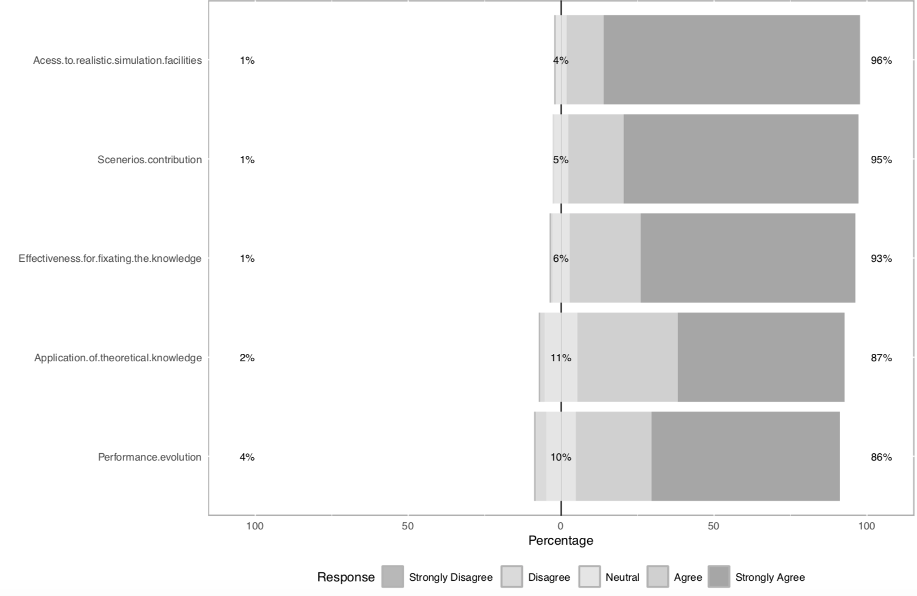

***Graph 3:*** Answers of Questionnaire Regarding the Section of Emotions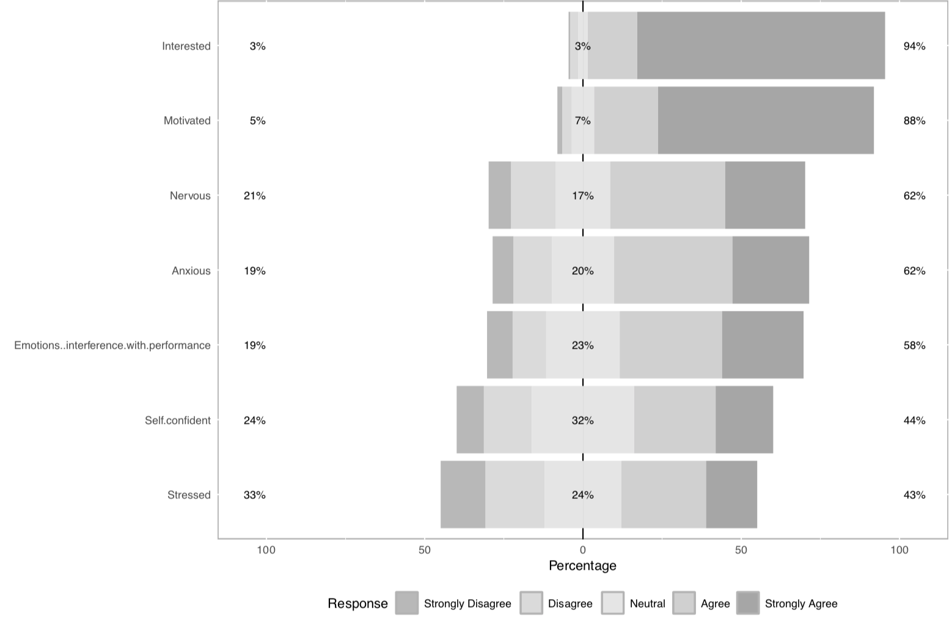

***Graph 4:*** Answers of Questionnaire Regarding the Section of Skills

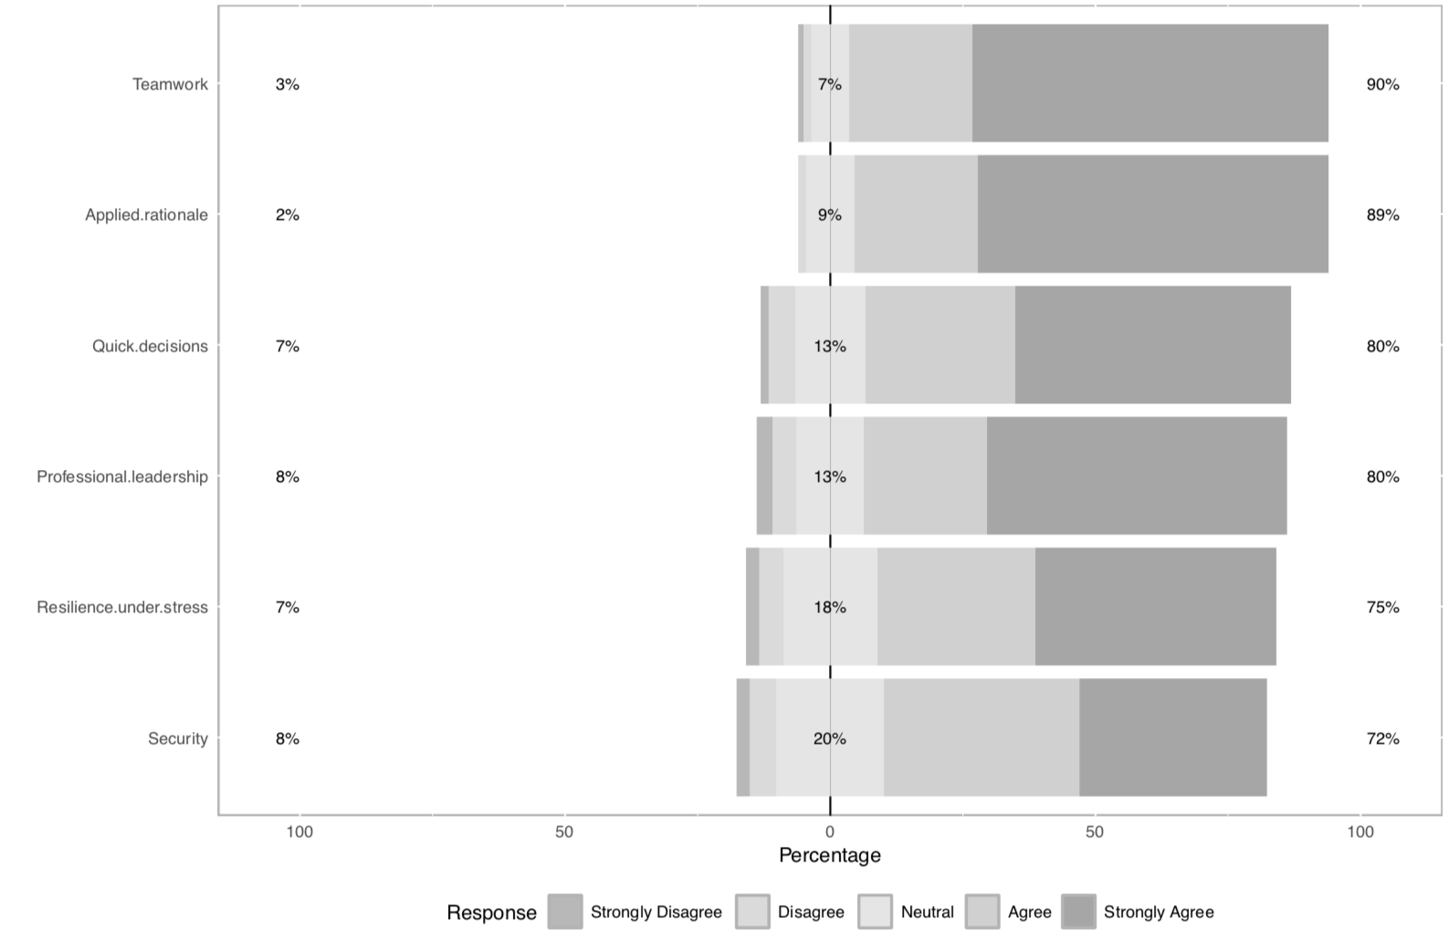

***Graph 5:*** Answers of Questionnaire Regarding the Section of Debriefing

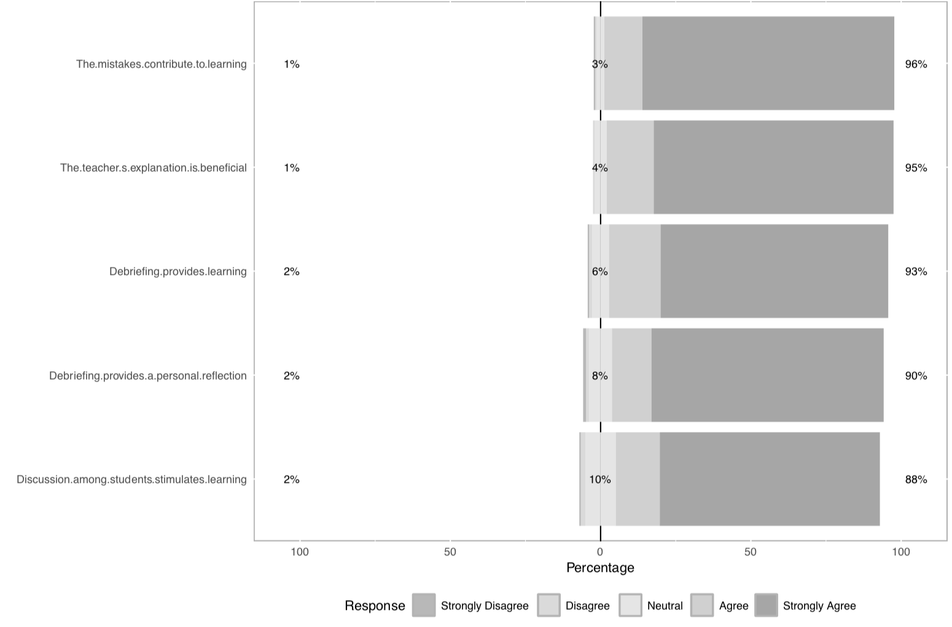

***Table 1:*** Summary of Key Themes, Number of Responses and Example Quotations from the Open-Ended Question: “Would you change anything in the application of the scenarios?”

|  |  |  |
| --- | --- | --- |
| **Theme** | **Number of responses** | **Example Quotation(s)** |
| No changes suggested | 33 | "No. They're great. That's where I learned the most in Physiology.” |
| Request for more deliberate practice | 20 | “I would create more scenarios and put fewer people in each scenario.” |
| Integration with theorical classes | 4 | “Choose topics that are being studied in theoretical classes when carrying out the scenario.” |
| Longer or more complete debriefing | 4 | “Teachers could prepare material so that the debriefing is not just in the oral dimension.” |
| Faster and less in-depth debriefing | 1 | "The teacher could spend less time explaining in the debriefing, making the class more dynamic and less tiring” |
| Application in other subjects | 4 | “Add them to DIC (Curriculum Integration Discipline) and have it every semester.” |
| Application in advanced semesters | 1 | “I would place the scenarios in all periods.” |
| Need for emotional preparation | 1 | “Emotional preparation to avoid exacerbated anxiety before the scenarios.” |
| Reduced pressure by not grading | 2 | “Everything, I would make it a class instead of a test.” |

***Table 2:*** Association Between Students’ Perception of Human Physiology Practical Classes and the Sum Score of the Questionnaire's Sections